ITA0510 COMPUTER VISION
LAB ACTIVITY:
11. Affine Transformation on the Image
AIM
To perform Affine Transformation on an image using OpenCV.
ALGORITHM
- Import the required libraries cv2 and numpy.
- Read the input image using cv2.imread().
- Get the number of rows and columns of the image.
- Create a 2 × 3 affine transformation matrix.
- Apply the affine transformation using cv2.warpAffine().
- Save the transformed image using cv2.imwrite().
- Display the resulting transformed image.
PROGRAM
import cv2
import numpy as np
from google.colab.patches import cv2_imshow
from google.colab import files

uploaded = files.upload()

img = cv2.imread(next(iter(uploaded)))

rows, cols = img.shape[:2]

M = np.float32([
[1, 0, 100],
[0, 1, 50]
])

affine_img = cv2.warpAffine(img, M, (cols, rows))

print("Original Image:")
cv2_imshow(img)

print("Affine Transformed Image:")
cv2_imshow(affine_img)

cv2.imwrite("Affine_Transformed.jpg", affine_img)
OUTPUT:
• yu-chin-tsai-piTEABtlR1Q-unsplash.jpg(image/jpeg) - 1589159 bytes, last modified: 7/13/2026 - 100% done
Saving yu-chin-tsai-piTEABtlR1Q-unsplash.jpg to yu-chin-tsai-piTEABtlR1Q-unsplash (1).jpg
Original Image:
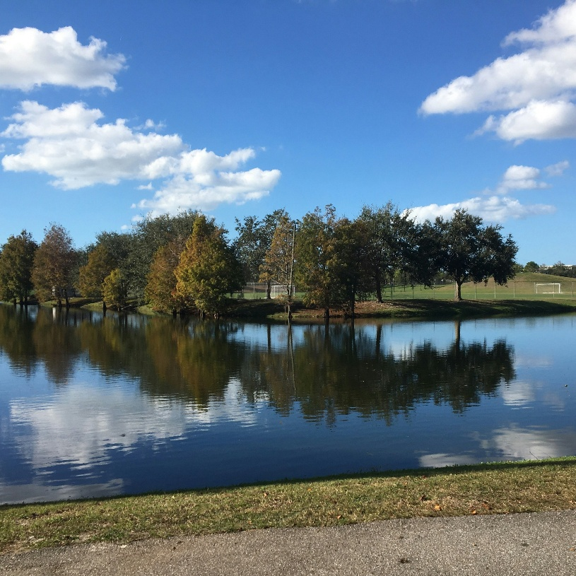
Affine Transformed Image:
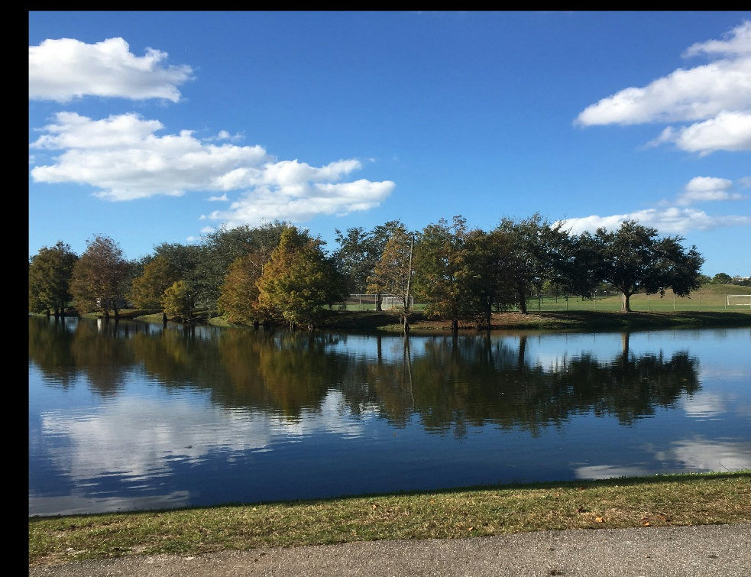
True
RESULT
The Affine Transformation was successfully performed on the given image using OpenCV in Google Colab. The image was translated 100 pixels to the right and 50 pixels downward, and the transformed image was saved as Affine_Transformed.jpg.
12. Perspective Transformation on the Image
AIM
To perform Perspective Transformation on an image using OpenCV in Google Colab.
ALGORITHM
- Import the required libraries cv2 and numpy.
- Upload the input image to Google Colab.
- Read the uploaded image using cv2.imread().
- Get the number of rows and columns of the image.
- Define four source points from the original image.
- Define four corresponding destination points.
- Calculate the perspective transformation matrix using cv2.getPerspectiveTransform().
- Apply the transformation using cv2.warpPerspective().
- Display the original and transformed images.
- Save the transformed image as Perspective_Transformed_Image.jpg.
PROGRAM
import cv2
import numpy as np
from google.colab.patches import cv2_imshow
from google.colab import files

uploaded = files.upload()

img = cv2.imread(next(iter(uploaded)))

rows, cols = img.shape[:2]

src_points = np.float32([
[0, 0],
[cols - 1, 0],
[0, rows - 1],
[cols - 1, rows - 1]
])

dst_points = np.float32([
[0, 0],
[cols - 1, 0],
[int(0.33 * cols), rows - 1],
[int(0.66 * cols), rows - 1]
])

M = cv2.getPerspectiveTransform(src_points, dst_points)

perspective_img = cv2.warpPerspective(img, M, (cols, rows))

print("Original Image:")
cv2_imshow(img)

print("Perspective Transformed Image:")
cv2_imshow(perspective_img)
cv2.imwrite("Perspective_Transformed_Image.jpg", perspective_img)
OUTPUT:
• yu-chin-tsai-piTEABtlR1Q-unsplash.jpg(image/jpeg) - 1589159 bytes, last modified: 7/13/2026 - 100% done
Saving yu-chin-tsai-piTEABtlR1Q-unsplash.jpg to yu-chin-tsai-piTEABtlR1Q-unsplash (2).jpg
Original Image:
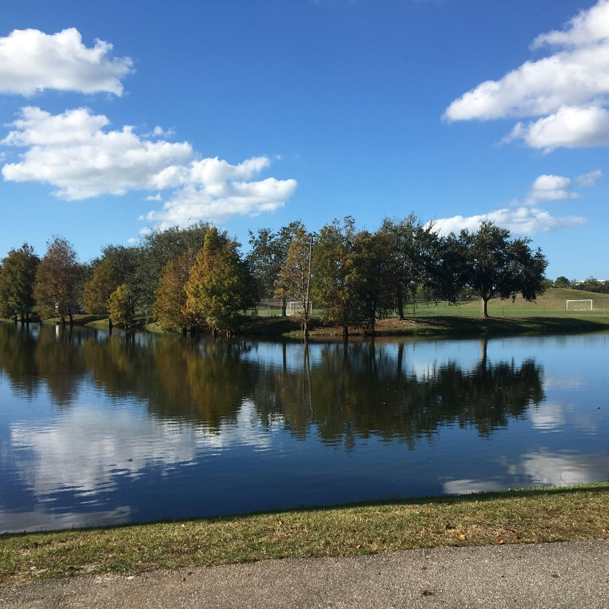
Perspective Transformed Image:
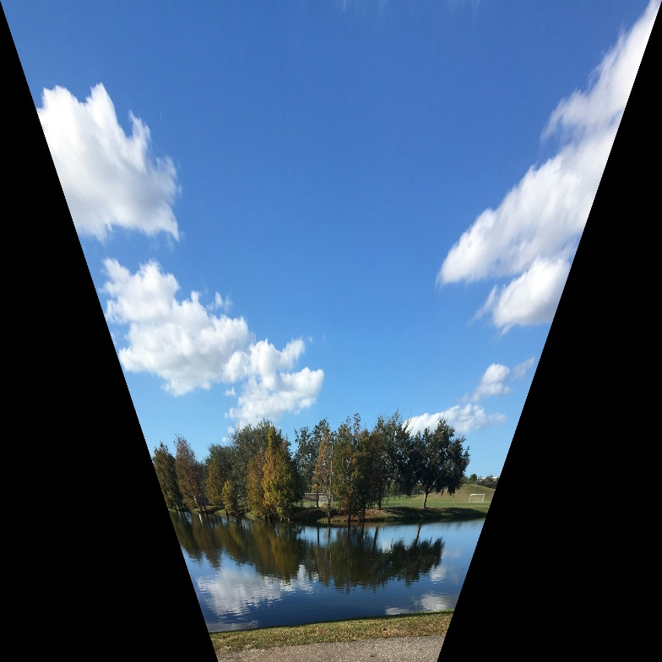
True
RESULT
The Perspective Transformation was successfully performed on the given image using OpenCV in Google Colab. The transformed image was saved as Perspective_Transformed_Image.jpg.
13. Perspective Transformation on the Video
AIM
To perform Perspective Transformation on a video using OpenCV.
ALGORITHM
- Import the required libraries cv2 and numpy.
- Define four points from the input video frame.
- Define four corresponding destination points.
- Calculate the perspective transformation matrix using cv2.getPerspectiveTransform().
- Open the camera using cv2.VideoCapture(0).
- Read video frames continuously.
- Apply perspective transformation using cv2.warpPerspective().
- Display the original and transformed frames.
- Press q to stop the video.
- Release the camera and destroy all OpenCV windows.
PROGRAM
import cv2
import numpy as np
from google.colab import files

uploaded = files.upload()

roi_points = np.array([
(150, 200),
(450, 200),
(550, 500),
(50, 500)
])

target_points = np.array([
(0, 0),
(400, 0),
(400, 600),
(0, 600)
])

M = cv2.getPerspectiveTransform(
roi_points.astype(np.float32),
target_points.astype(np.float32)
)

cap = cv2.VideoCapture(0)

while True:
ret, frame = cap.read()

if not ret:
break

dst = cv2.warpPerspective(frame, M, (400, 600))

cv2.imshow("Original Frame", frame)
cv2.imshow("Transformed Frame", dst)

if cv2.waitKey(1) & 0xFF == ord('q'):
break

cap.release()
cv2.destroyAllWindows()
OUTPUT:
sample_video.mp4(video/mp4) - 106115604 bytes, last modified: 7/20/2026 - 100% done
Saving sample_video.mp4 to sample_video.mp4
RESULT
Thus, the Perspective Transformation was successfully performed on the video using OpenCV. The selected region of each video frame was transformed into the specified destination dimensions.

14. Transformation Using Homography Matrix
AIM
To perform transformation on an image using a Homography Matrix in OpenCV.
ALGORITHM
- Import the required libraries cv2 and numpy.
- Upload the input image to Google Colab.
- Read the uploaded image.
- Get the number of rows and columns of the image.
- Define the source points and destination points.
- Calculate the Homography Matrix using cv2.findHomography().
- Apply the transformation using cv2.warpPerspective().
- Display the original and transformed images.
- Save the transformed image.
PROGRAM
import cv2
import numpy as np
from google.colab import files
from google.colab.patches import cv2_imshow

uploaded = files.upload()

img = cv2.imread(next(iter(uploaded)))

rows, cols = img.shape[:2]

src_points = np.float32([
[0, 0],
[cols - 1, 0],
[0, rows - 1],
[cols - 1, rows - 1]
])

dst_points = np.float32([
[0, 0],
[cols - 1, 0],
[0, int(0.7 * rows)],
[cols - 1, int(0.7 * rows)]
])

M, _ = cv2.findHomography(src_points, dst_points)

homography_img = cv2.warpPerspective(
img, M, (cols, rows)
)

cv2_imshow(img)

cv2_imshow(homography_img)

cv2.imwrite(
"transformation_using_Homography_Image.jpg",
homography_img
)

OUTPUT:
• yu-chin-tsai-piTEABtlR1Q-unsplash.jpg(image/jpeg) - 1589159 bytes, last modified: 7/13/2026 - 100% done
Saving yu-chin-tsai-piTEABtlR1Q-unsplash.jpg to yu-chin-tsai-piTEABtlR1Q-unsplash (3).jpg
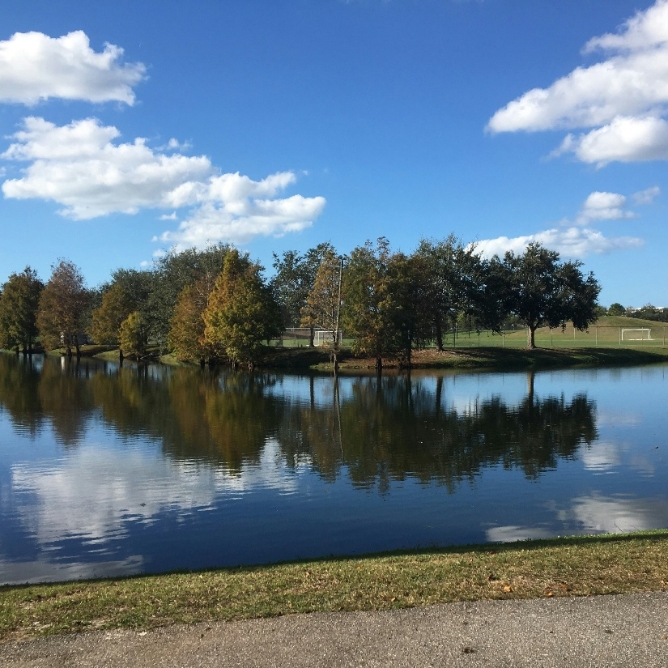
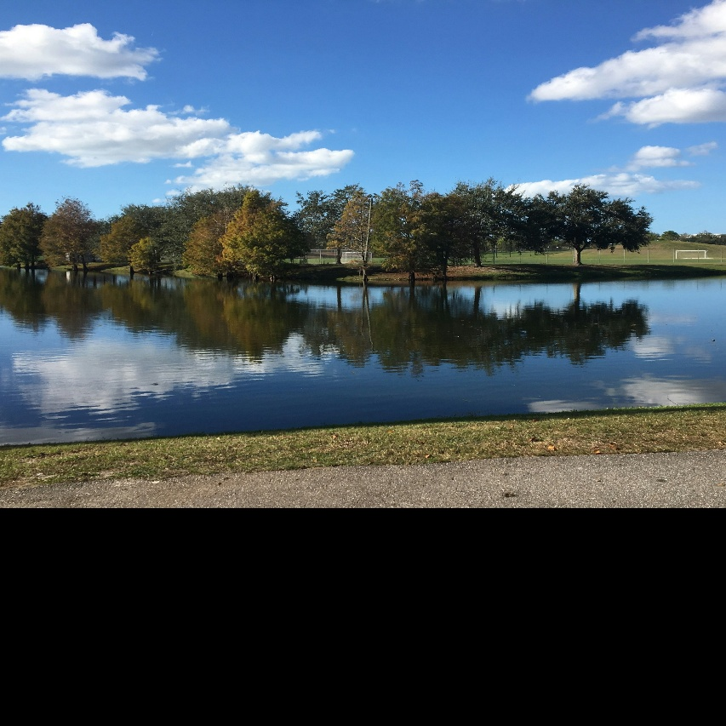
True
RESULT
Thus, the transformation using a Homography Matrix was successfully performed on the given image using OpenCV, and the transformed image was saved as transformation_using_Homography_Image.jpg.

15. Transformation Using Direct Linear Transformation (DLT)
AIM
To perform transformation using Direct Linear Transformation (DLT) on an image.
ALGORITHM
- Import cv2 and numpy.
- Upload and read the input image.
- Define corresponding source and destination points.
- Construct the DLT matrix using the point correspondences.
- Compute the Homography matrix using Singular Value Decomposition (SVD).
- Normalize the Homography matrix.
- Apply the transformation using cv2.warpPerspective().
- Display and save the transformed image.
PROGRAM
import cv2
import numpy as np
from google.colab import files
from google.colab.patches import cv2_imshow

uploaded = files.upload()

img = cv2.imread(next(iter(uploaded)))

rows, cols = img.shape[:2]

src = np.float32([
[0, 0],
[cols - 1, 0],
[cols - 1, rows - 1],
[0, rows - 1]
])

dst = np.float32([
[50, 50],
[cols - 50, 30],
[cols - 30, rows - 50],
[30, rows - 30]
])

A = []

for (x, y), (u, v) in zip(src, dst):
A.append([-x, -y, -1, 0, 0, 0, x*u, y*u, u])
A.append([0, 0, 0, -x, -y, -1, x*v, y*v, v])

A = np.array(A)

U, S, Vt = np.linalg.svd(A)

H = Vt[-1].reshape(3, 3)

H = H / H[2, 2]

transformed = cv2.warpPerspective(img, H, (cols, rows))

print("Original Image:")
cv2_imshow(img)

print("DLT Transformed Image:")
cv2_imshow(transformed)

cv2.imwrite("DLT_Transformed_Image.jpg", transformed)

OUTPUT:
• yu-chin-tsai-piTEABtlR1Q-unsplash.jpg(image/jpeg) - 1589159 bytes, last modified: 7/13/2026 - 100% done
Saving yu-chin-tsai-piTEABtlR1Q-unsplash.jpg to yu-chin-tsai-piTEABtlR1Q-unsplash (4).jpg
Original Image:
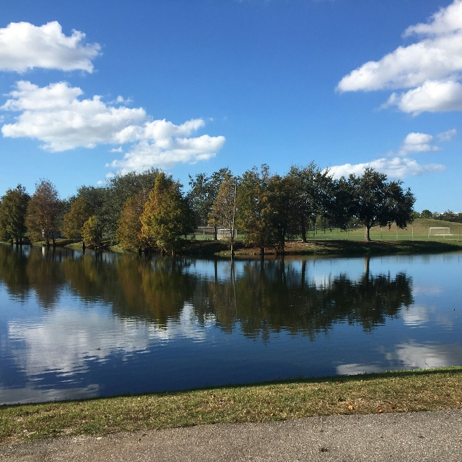
DLT Transformed Image:
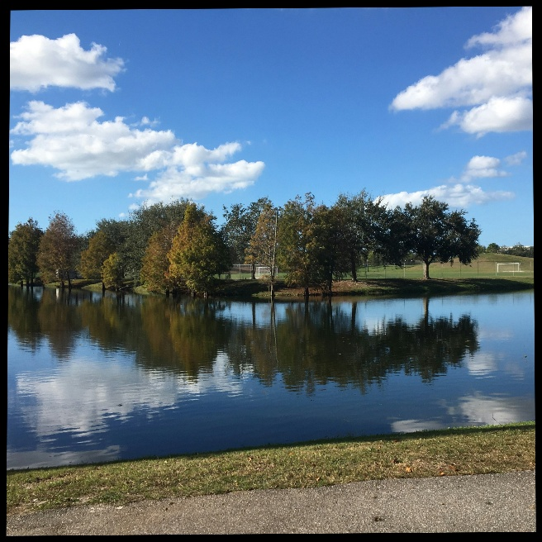
True

RESULT
Thus, the transformation using Direct Linear Transformation (DLT) was successfully performed on the given image, and the transformed image was saved as DLT_Transformed_Image.jpg.

